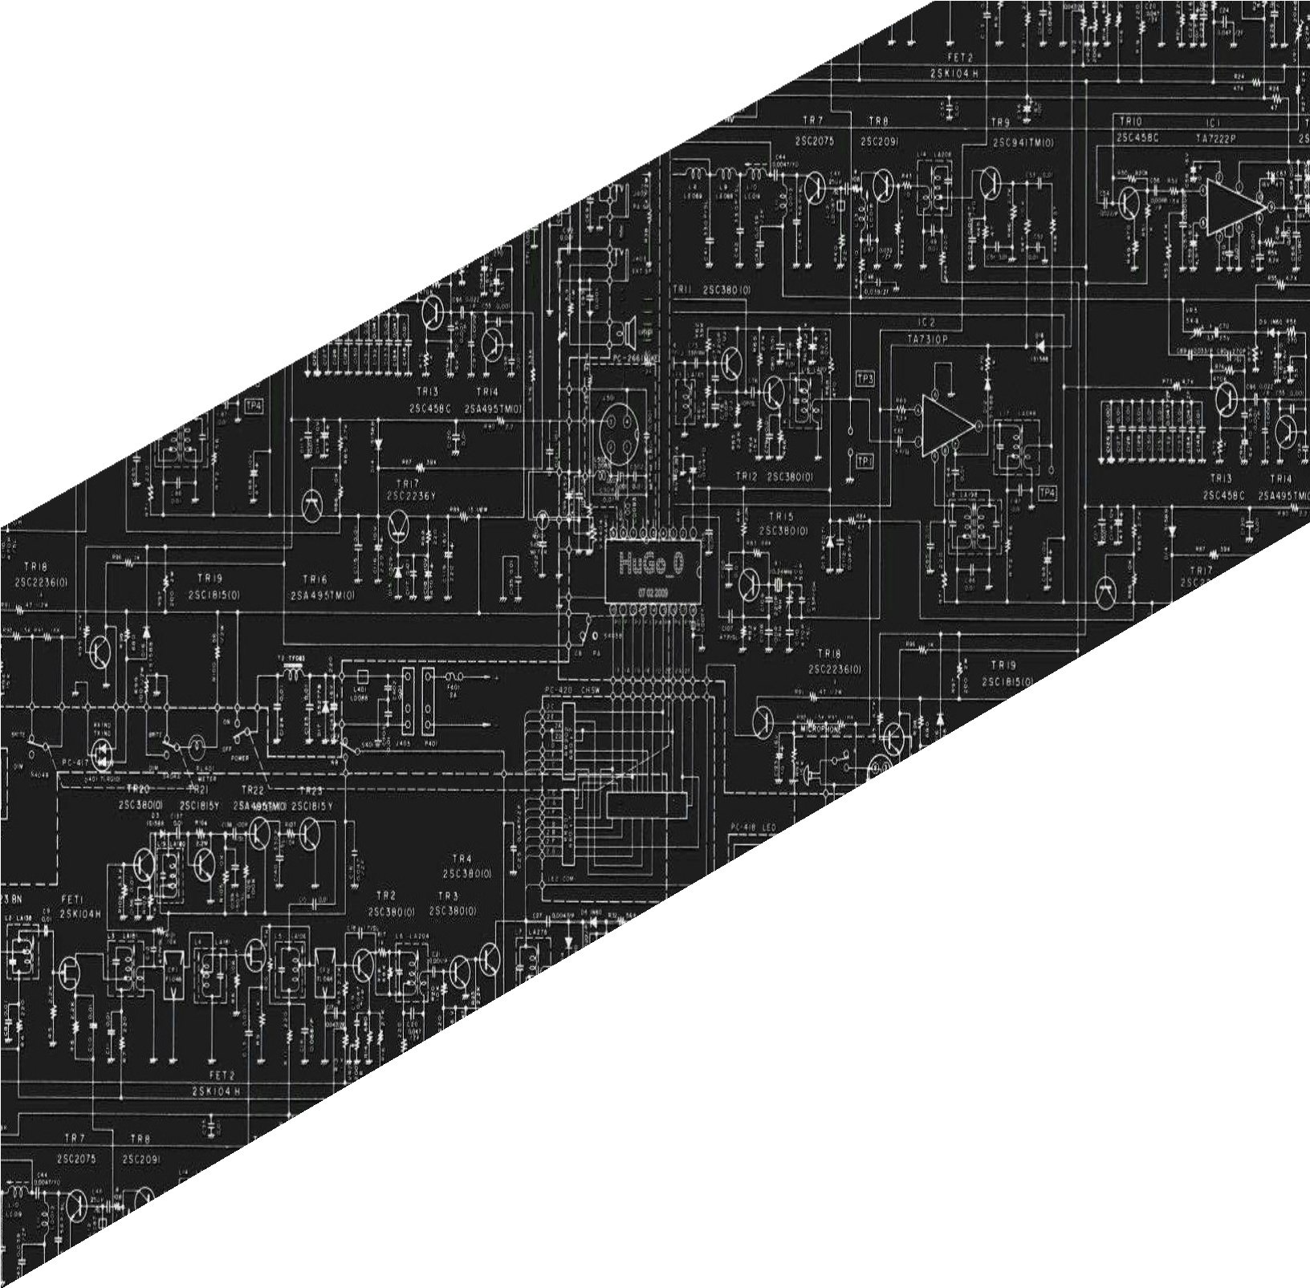



**PANGASINAN STATE UNIVERSITY**

URDANETA CITY CAMPUS

SECOND SEMESTER, AY 2021-2022

LABORATORY

REPORT

CpE222 SOFTWARE DESIGN

**SUBMITTED BY**

**Lendl Johnfil M. Claro**

**SUBMITTED TO**

**Engr. Jay-Ar M. Pentecostes**

**Laboratory Activity 01**

**“JOB APPLICATION WEBSITE”**

**USABILITY:**

When we are instead talking digital, then we consider usability as the ease of use of a website or an app. It is an indicator showing whether or not a website is effective, easy to navigate and efficient from the users' point of view.

**SPEED:**

The speed is faster to load, it depends on the internet or mobile data.

**AESTHETICS:**

Simple Aesthetics. Simple choices of colors, just a simple website that works for everyone.

**CONTENT:**

Login, Register, Search Bar, Application,

**WEBSITE MAINTENANCE:**

None

**MOBILE-FRIENDLY:**

No.

PURPOSE OF THE DOCUMENT:

To make a website or job application website that can apply the employees and do the job application.

DESCRIPTION OF THE PROJECT:

This project aimed at developing or building a job application website for job seekers. The system project is an online web application which can be accessed anywhere only with proper login and proper registration form provided.

FRONT-END FUNCTIONALITY:

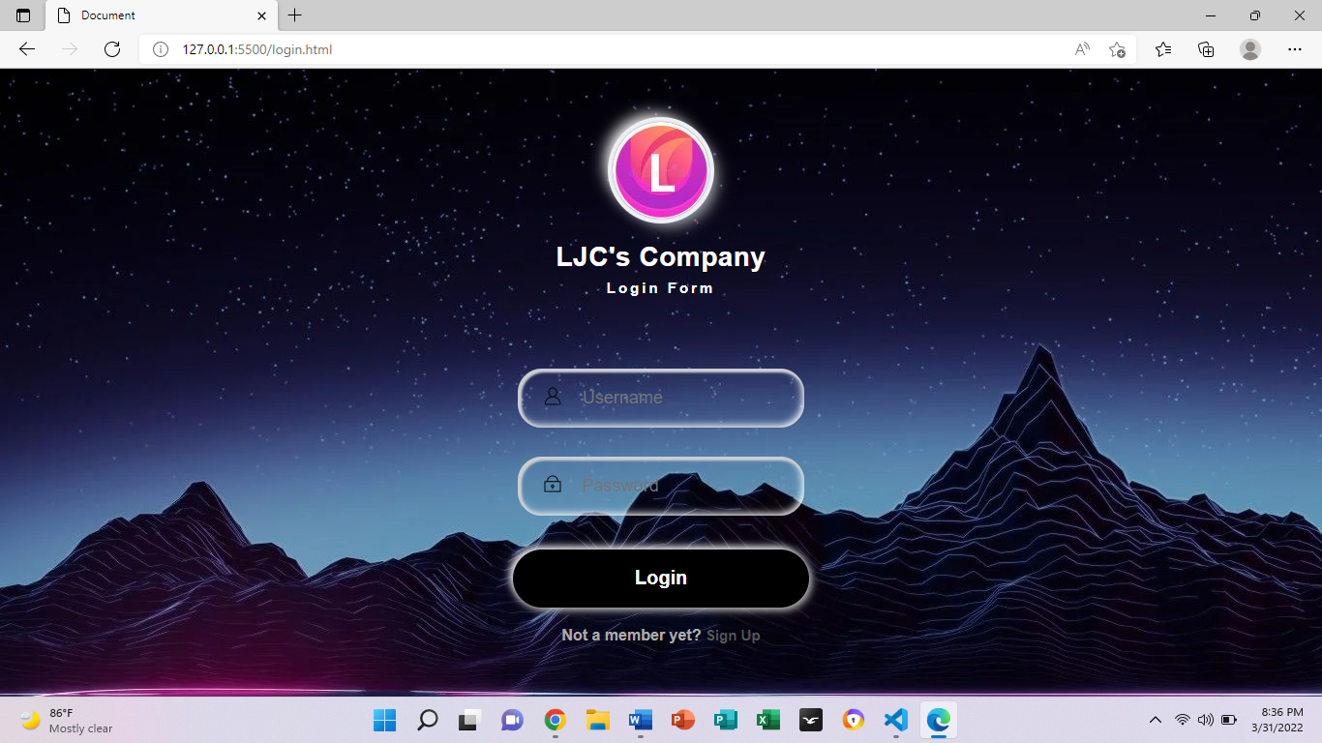

COMMON FEATURES:

You can make an account to register or you can login if you already have an account for the company’s website. You can see homepage where the profile, information about the company, privacy policy, contact us and sign out, he ca also see the apply now where he/she submit his/her cv or apply a job and lastly learn more.

SITEMAP AND WEBSITE STRUCTURE:

Sign In

Sign Up

Login

Homepage

Contact Us

Privacy Policy

Information

Your Profile

Sign Out

Learn More

Apply Now

DESCRIPTION OF EVERY WEBSITE PAGE:

Login where a user can input his/her account and password, or register to the registration form that can input his/her information to apply to the company. Homepage where the user sees the profile, information about the company, privacy policy, contact us and sign out, he ca also see the apply now where he/she submit his/her cv or apply a job and lastly learn more.

WIREFRAMES:

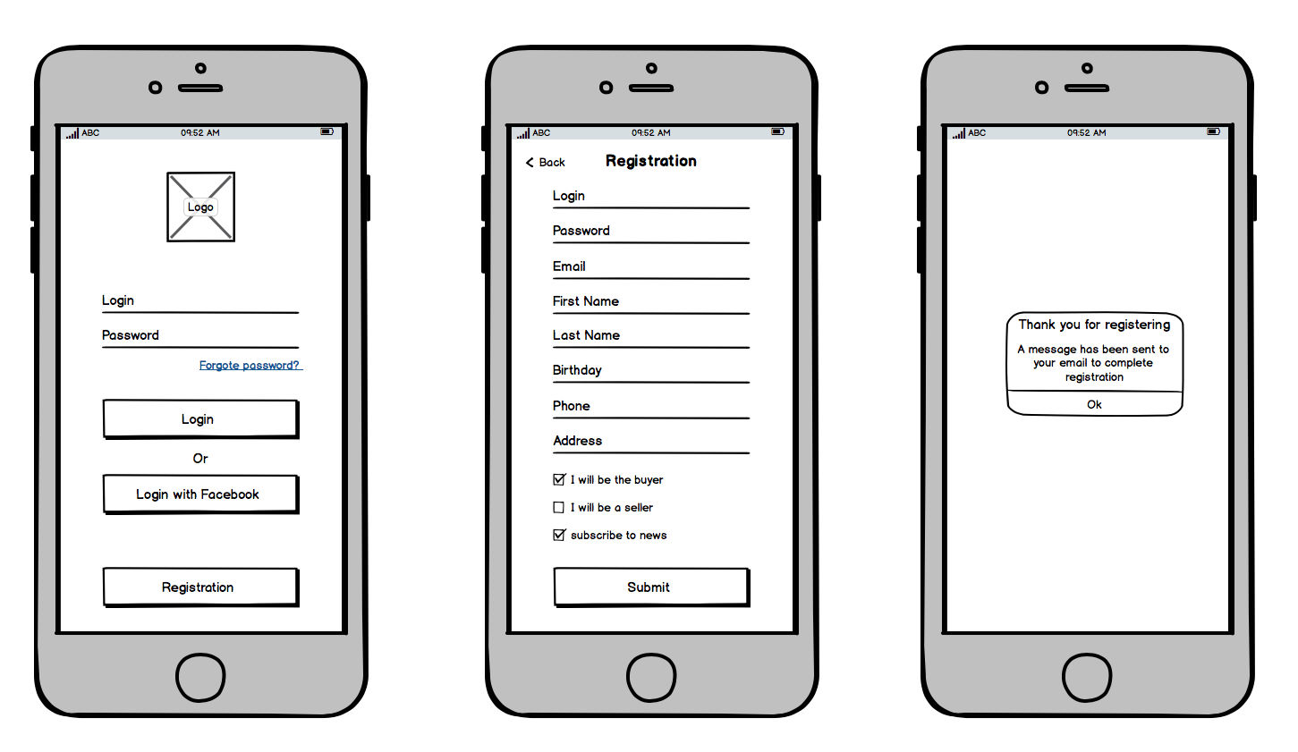

MISCELLANEOUS FUNCTIONALITY:

EXAMPLE:

**<html>**

**<head>**

**<title>Website</title>**

**<link rel="stylesheet" href="homepage.css">**

**</head>**

**<body>**

**<div class="banner">**

**<div class="navbar">**

**<img src="l.jpg" class="logo">**

**<ul>**

**<li><a href="profile.html">Your Profile</a></li>**

**<li><a href="information.html">Information</a></li>**

**<li><a href="privacypolicy.html">Privacy Policy</a></li>**

**<li><a href="contactus.html">Contact Us</a></li>**

**<li><a href="login.html">Sign Out</a></li>**

**</ul>**

**</div>**

**</div>**

**<div class="content">**

**<h1 id="logo">Welcome to LJC's Company!!!!</h1>**

**<p>Happy to Serve!!!</p>**

**<div>**

**<button type="submit-button"><a href="applynow.html">Apply Now</a></a></button>**

**<button type="submit-button"><a href="learnmore.html">Learn More</a></a></button>**

**</div>**

**</div>**

**</div>**

**</body>**

**</html>**

BACK-END FUNCTIONALITY:

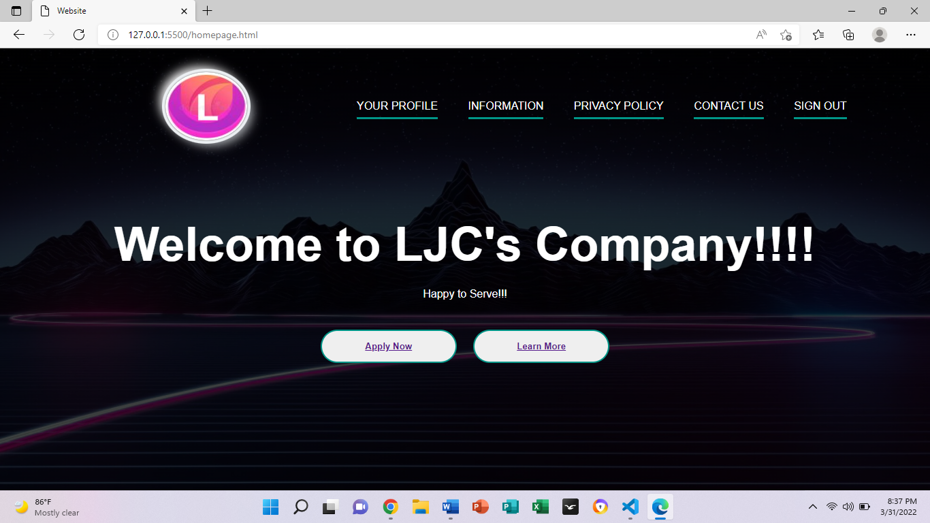

USE CASES:

CONCLUSION:

In Conclusion, we make the website through html and css, we know how to create a simple website design and the main concept of the website. We can used this as our job application that an employee can submit his/her application form.

DOCUMENTATION:



